INDIAN INSTITUTE OF TECHNOLOGY, JODHPUR





**DESIGN CREDIT PROJECT**

# BIDIRECTIONAL BATTERY CHARGER FOR ELECTRIC VEHICLE

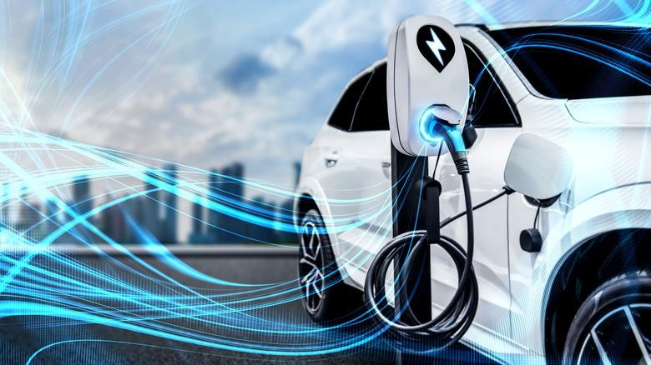

**DESIGN/PRACTICAL EXPERIENCE**

# DEPARTMENT OF ELECTRICAL ENGINEERING

**Professor Kunwar Aditya**

**Academic Year: 2023-2024**

**Semester: 4th**

**Date of Submission of Report:**

**Name of Student: Gaurav Naval (B21EE020)**

**Name of Student: Pawar Aditya Hanmant (B21EE048)**

**Title Of Project: Bidirectional Battery Charger for Electric Vehicle**

**AIM**

## To develop the model(circuit) of a bidirectional battery charger on MATLAB.

**BACKGROUND**

**Stage-1**: Learnt MATLAB and made several circuits initially ( For learning Purposes )



**Stage-2**: Study of Literature/Research Papers

Rigorously went through research papers studying diﬀerent parameters related to Bidirectional Battery Chargers. Understood the mechanism of MOSFET, thyristor, and linear transformers.

## **A BRIEF ABOUT BIDIRECTIONAL BATTERY CHARGER**

A bidirectional battery charger is a type of charging system that can both charge and discharge a battery. This means that it can take energy from a power source, such as a grid, and use it to charge a battery. It can also take energy from the battery and send it back to the grid or use it to power other devices. One of the main advantages of bidirectional battery chargers is that they can be used in a variety of applications, such as renewable energy systems, electric vehicles, and energy storage systems. They can help to improve the efficiency and reliability of these systems, as well as reduce their overall costs.

In addition, bidirectional battery chargers can also help to address some of the challenges associated with the integration of renewable energy sources into the grid. They can help to smooth out fluctuations in power supply and demand, as well as provide backup power in the event of a blackout or other power outage.

## **WHY DO WE NEED A BIDIRECTIONAL BATTERY CHARGER?**

* **Energy Storage**: Bidirectional battery charging allows us to store energy from renewable sources, such as solar or wind power, in a battery for later use. This enables us to balance power supply and demand and reduces the need for expensive and environmentally harmful energy storage options, such as fossil fuel generators.
* **Grid Resiliency**: Bidirectional battery charging provides a reliable backup power source that can be used during blackouts and other power outages. In addition, it can help to improve the resiliency of the electrical grid by enabling energy to be stored during times of low demand and then released during periods of peak demand.
* **Electric Vehicle Charging:** Bidirectional battery charging allows electric vehicles to not only receive power from the grid but also supply power back to the grid. This helps to balance the grid, reduce peak loads, and can potentially provide additional revenue streams for vehicle owners.
* **Cost Savings:** Bidirectional battery charging can help to reduce overall energy costs by allowing users to take advantage of time-of-use pricing, where electricity is cheaper during off-peak periods. This can encourage more efficient use of energy, lower overall costs, and reduce the need for expensive energy storage systems.
* **Environmental Benefits:** Bidirectional battery charging can help to reduce carbon emissions by enabling the efficient use of renewable energy sources and reducing the need for fossil fuel-based power generation. This can contribute to mitigating the impacts of climate change and improving overall air quality.
* **Distributed Energy Resources (DERs):** Bidirectional battery charging can facilitate the integration of distributed energy resources, such as rooftop solar panels or small-scale wind turbines, into the electrical grid. By allowing for the efficient storage and transfer of energy from these sources, bidirectional battery charging can help to increase the amount of renewable energy in the grid and reduce the reliance on centralized power generation. This can improve grid resiliency and promote a more sustainable energy future.

## **VEHICLE-TO GRID (V2G)**

Vehicle-to-grid (V2G) is a technology that enables electric vehicles (EVs) to not only receive power from the grid but also to supply power back to the grid. In a V2G system, the EV's battery can be used as a mobile energy storage system that can be charged during off-peak periods and discharged during peak periods, helping to balance the electrical grid.

* **Benefits:** V2G has several benefits. It can provide an additional source of revenue for EV owners by allowing them to sell excess energy back to the grid. It can also help to balance the electrical grid, reduce peak power demand, and improve the resiliency of the grid.
* **Challenges**: Despite the potential benefits of V2G, there are some technical and regulatory challenges that need to be addressed before it can become a widespread reality. One major challenge is the development of bidirectional battery charging technology that can handle the high-power levels required for V2G. Additionally, there are regulatory challenges related to the sale of energy back to the grid, as well as concerns about the impact of V2G on the lifespan of EV batteries.
* **Current Status and Future Outlook:** The implementation of V2G using bidirectional battery charging technology is still in the early stages of development, with several pilot projects and research initiatives currently underway. However, the potential benefits of V2G are significant, and many researchers and industry experts are working to overcome the technical and regulatory challenges involved.

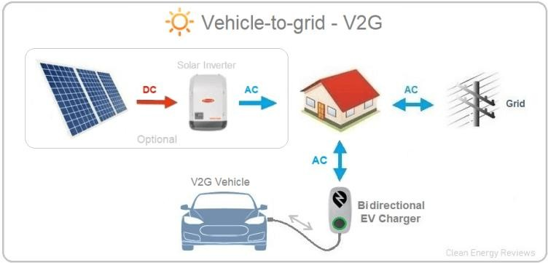

## **VEHICLE-TO-HOME (V2H)**

Vehicle-to-home (V2H) is a technology that allows electric vehicles (EVs) to provide power to a home during power outages or emergencies. In a V2H system, the EV's battery can be used as a backup power source for critical household appliances, such as lights, refrigerators, and heating and cooling systems. power in the event of a blackout.

#### Benefits:

**Backup power during outages:** V2H technology provides a source of backup power during power outages or emergencies. The battery of an EV can be used to power a home's electrical appliances, providing critical support during emergencies.

**Reduced strain on the grid:** V2H technology can help reduce the strain on the electrical grid during peak demand periods, thus reducing the likelihood of blackouts or brownouts.

**Energy storage:** V2H technology allows EV owners to use their vehicle's battery as a temporary energy storage solution. This can be useful for renewable energy integration and peak shaving.

#### Challenges:

**Battery lifespan:** The process of bidirectional battery charging can reduce the lifespan of an EV's battery, leading to reduced range and increased maintenance costs.

**Safety concerns:** There are safety concerns associated with connecting an EV to a home's electrical system. Improper installation or use can result in electrical shock, fire, or other hazards.

**Compatibility issues:** Different EVs have different charging requirements and compatibility with different types of charging infrastructure. This can make it difficult for EV owners to take advantage of V2H technology.

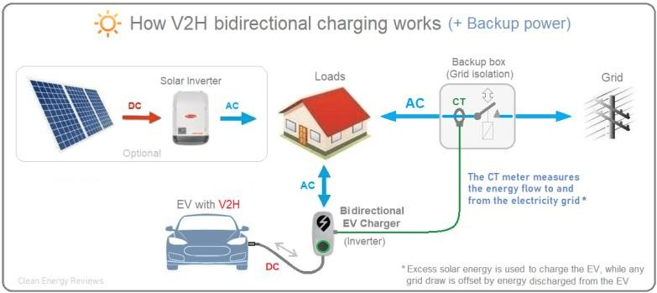

## **VEHICLE TO LOAD (V2L)**

Vehicle-to-load (V2L) is a technology that allows electric vehicles (EVs) to power external devices or equipment through the vehicle's charging port. In a V2L system, the EV's battery can be used as a source of power for a variety of applications, such as powering tools and appliances at job sites or outdoor events.

* **Benefits:** V2L technology has several benefits. It provides a portable and reliable source of power that can be used for a variety of applications, without the need for a dedicated generator or power source. It can also help to reduce emissions and noise pollution by replacing gasoline- powered equipment with electric-powered equipment.

#### Challenges:

**Power quality:** V2L technology can introduce power quality issues such as harmonic distortion, voltage fluctuation, and power factor problems, which can affect the performance of electrical equipment and appliances.

**Load management:** V2L technology requires effective load management to ensure that the electrical load on the EV battery does not exceed its capacity, leading to reduced battery lifespan and potential safety hazards.

**Infrastructure requirements:** V2L technology requires additional infrastructure to be installed to enable bi-directional power flow, including power electronics, control systems, and communication protocols. This can add complexity and cost to the system.

**System efficiency:** The efficiency of V2L systems can vary depending on the type of equipment used, the condition of the EV battery, and the electrical load being powered. Poor system efficiency can lead to wasted energy and reduced cost savings.

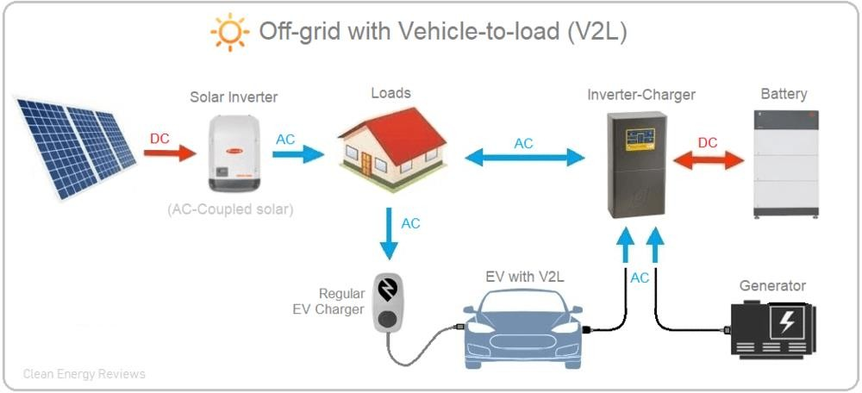

## **BENEFITS OF BIDIRECTIONAL BATTERY CHARGER**

* **Grid Stabilization:** Bidirectional charging allows electric vehicles to supply power back to the grid during peak demand periods, helping to stabilize the grid and reduce the need for expensive peaking power plants. This can help to improve the overall reliability and stability of the power grid.
* **Energy Storage:** Bidirectional charging also allows electric vehicles to function as mobile energy storage units, storing excess renewable energy generated during low-demand periods and supplying it back to the grid during high-demand periods. This can help to smooth out the variability of renewable energy sources and reduce the need for expensive energy storage facilities.
* **Cost Savings:** By reducing the need for peaking power plants and expensive energy storage facilities, bidirectional charging can help to reduce overall energy costs for utilities and consumers.
* **Environmental Benefits:** Bidirectional charging can help to reduce greenhouse gas emissions by enabling greater use of renewable energy sources and reducing the need for fossil fuel-based peaking power plants.
* **Increased EV Adoption:** By offering additional benefits to electric vehicle owners, such as the ability to earn money by selling power back to the grid, bidirectional charging can help to increase the adoption of electric vehicles and accelerate the transition to a more sustainable energy future.

## **COMPONENTS REQUIRED**

#### MOSFET

**MOSFETs (Metal-Oxide-Semiconductor Field-Effect Transistors)** are commonly used in bidirectional battery charging due to their ability to switch high currents at high frequencies and their low on-resistance, which results in low power dissipation.

In the **full-bridge topology**, the MOSFETs are used to control the direction and magnitude of the charging and discharging currents. Specifically, the MOSFETs are turned on and off in a specific sequence to **modulate** the current flow in the desired direction.

During charging, the MOSFETs can be used to switch the charging current so that it flows into the battery. During discharging, the MOSFETs can be used to switch the discharging current so that it flows out of the battery. By controlling the timing and sequence of the MOSFETs,

bidirectional battery charging can be achieved.

One **advantage** of using MOSFETs in bidirectional battery charging is that they are **highly efficient** and can **switch high currents at high frequencies**. This allows for **precise control** over the charging and discharging currents, which can help to **extend the lifetime** of the battery and **improve overall system efficiency.**

However, MOSFETs can be sensitive to overvoltage and overcurrent conditions, and require appropriate protection and control circuits to ensure safe and reliable operation.

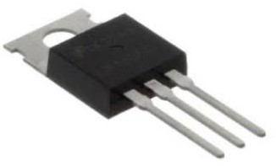

#### LINEAR TRANSFORMER

A linear transformer can be used in bidirectional battery charging to isolate the charging and discharging circuits and to control the direction of power flow. A linear transformer is a type of transformer that operates on the principle of electromagnetic induction to transfer energy from one circuit to another.

In bidirectional battery charging, a linear transformer can be used to control the direction of power flow between the battery and the charging/discharging source. Specifically, the transformer can be used to convert the high-frequency pulses generated by the pulse generator into a low-frequency AC voltage that can be used to control the charging and discharging currents.

During charging, the linear transformer can be used to convert the high-frequency pulses generated by the pulse generator into a low-frequency AC voltage that is applied to the battery. This voltage is then rectified by a rectifier circuit to produce a unidirectional charging current that flows into the battery. During discharging, the linear transformer can be used to convert the high- frequency pulses generated by the load into a low-frequency AC voltage that is applied to the charging source. This voltage is then rectified to produce a unidirectional discharging current that flows out of the battery.

One advantage of using a linear transformer in bidirectional battery charging is that it provides **galvanic isolation** between the battery and the charging/discharging source. This helps to protect the battery and the charging/discharging source from voltage transients and other electrical disturbances

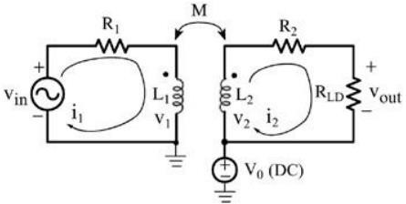

#### PULSE GENERATOR

a pulse generator is used to control the direction and magnitude of the charging and discharging currents. Specifically, the pulse generator can be used to modulate the charging and discharging currents so that they are unidirectional, meaning they only flow in one direction at any given time

**To achieve bidirectional battery charging**, a pulse generator is often used in conjunction with a power electronic converter. The converter is responsible for regulating the current flow between the battery and the charging/discharging source, while the pulse generator is used to modulate the current flow in the desired direction.

For **example**, during charging, the pulse generator can be used to generate pulses that are synchronized with the charging source. These pulses can be used to control the charging current so that it flows into the battery in a **unidirectional manner**. During discharging, the pulse generator can be used to generate pulses that are synchronized with the load. These pulses can be used to control the discharging current so that it flows out of the battery in a unidirectional manner.

By using a pulse generator in bidirectional battery charging, the system can be designed to operate more **efficiently** and **effectively**, allowing for more precise control over the charging and discharging process. Additionally, this method can be used to **extend the lifetime of the battery** by reducing the stress on the battery during charging and discharging.

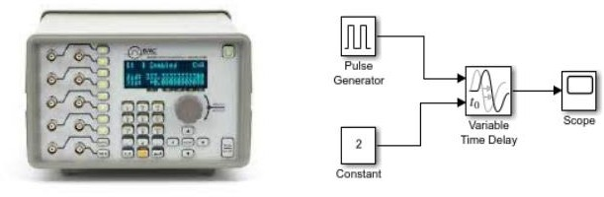

## **MODEL OF DUAL ACTIVE BRIDGE**

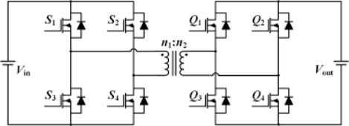

**WORKING PRINCIPLE**

The bidirectional battery charger model is based on a dual active bridge converter, which is a power electronics circuit that allows for the transfer of power in either direction between two sources. The principle on which this model works is that the direction of power flow is determined by the phase angle difference between the two power sources.

The dual active bridge converter consists of two power bridges, each of which contains two switches and

a transformer. The switches are controlled by a pulse-width modulation (PWM) signal, which allows the converter to regulate the voltage and current levels of the power flowing through it.

**During charging**, the bidirectional battery charger takes power from an AC source, such as the grid, and converts it into DC power to charge the battery. The dual active bridge converter adjusts the voltage and current levels of the power to ensure that the battery is charged at a safe and efficient rate.

**During discharging**, the bidirectional battery charger converts the DC power from the battery into AC power that can be used to power homes or businesses. The dual active bridge converter adjusts the voltage and current levels of the power to ensure that the AC power output is stable and meets the requirements of the load.

The bidirectional battery charger model allows for efficient and flexible use of energy storage systems, as it enables power to be transferred in either direction between the battery and the grid. This technology is becoming increasingly important as the use of renewable energy sources like solar and wind power grows, as it allows excess energy to be stored and used when needed, and helps to balance the grid by providing backup power during blackouts and absorbing excess energy during low-demand periods.

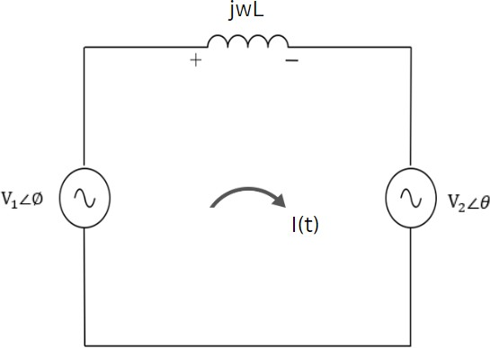

**DERIVATION**

# AC POWER TRANSFER

### Power we can send from one source to another:

#### (Fig-1)

𝑰(𝒕) = (𝑽𝟏∠∅) − (𝑽𝟐∠𝜽)

𝒋𝒘𝑳

### , Where ∠∅ = ∠𝟎° (Phase shift with reference to Voltage)

𝑰(𝒕) = 𝑽𝟏 𝐬𝐢𝐧(𝒘𝒕) − 𝑽𝟐 𝒔𝒊𝒏(𝒘𝒕 − 𝜽)

𝒘𝑳 𝒘𝑳

### **P(t) =** (𝑽𝟐∠𝜽) 𝑰(𝒕) (Power) As, 𝑽𝟐∠𝜽 = 𝑽𝟐 𝐜𝐨𝐬(𝒘𝒕 − 𝜽)

𝑷(𝒕) = (𝑽𝟐 𝐜𝐨𝐬(𝒘𝒕 − 𝜽))𝑰(𝒕)

### 𝑷(𝒕) = (𝑽

𝐜𝐨𝐬(𝒘𝒕 − 𝜽)) [𝑽𝟏 𝐬𝐢𝐧(𝒘𝒕) − 𝑽𝟐 𝒔𝒊𝒏(𝒘𝒕 − 𝜽)]

𝟐 𝒘𝑳

𝒘𝑳

### 𝑷(𝒕) = (𝑽𝟏 𝑽𝟐 . 𝐜𝐨𝐬(𝒘𝒕 − 𝜽) . 𝐬𝐢𝐧(𝒘𝒕)) − ((𝑽𝟐)𝟐 . 𝐜𝐨𝐬(𝒘𝒕 − 𝜽) . 𝒔𝒊𝒏(𝒘𝒕 − 𝜽) )

𝒘𝑳 𝒘𝑳

### If we find Average Power < 𝑃 > over 1 Cycle, (cos(𝑤𝑡 − 𝜃) . 𝑠𝑖𝑛(𝑤𝑡 − 𝜃) ) will be Neglected

𝑽 𝑽

𝟏 𝟐

### 𝑷(𝒕) = (

𝒘𝑳

### . 𝐜𝐨𝐬(𝒘𝒕 − 𝜽) . 𝐬𝐢𝐧(𝒘𝒕))

**Average Power** < 𝑷 >

< 𝑷 > = 𝟏 ∫𝑻 𝑷(𝒕) 𝒅𝒕

𝑻 𝟎

< 𝑷 > = 𝑽𝟏 𝑽𝟐 × 𝟏 ∫𝑻(𝐜𝐨𝐬(𝒘𝒕 − 𝜽) . 𝐬𝐢𝐧(𝒘𝒕)) 𝒅𝒕

𝒘𝑳

𝑻 𝟎

< 𝑷 > = 𝑽𝟏 𝑽𝟐

𝒘𝑳

### × 𝐬𝐢𝐧 𝜽

(Average Power < 𝑷 > Will be Maximum at 𝜃 = 90° and Minimum at 𝜃 = 0° )

**Depending on the Angle** 𝜽 **we can send power from one source to another, In Fig-1, If** 𝜽 > 𝟎°**, Current will flow in the Clockwise direction**

**If** 𝜽 < 𝟎°**, Current will flow in the Anti- Clockwise direction**

Linear transformers have the unique ability to transfer power bidirectionally, which means they can facilitate the flow of power in either direction between two power sources. The direction of power flow is determined by the phase angle difference between the sources.

This bidirectional power transfer capability makes linear transformers ideal for managing power in scenarios such as transferring power from a vehicle to the grid or vice versa. During this transfer process, linear transformers can also amplify the voltage or current magnitude to optimize the efficiency of the power transfer.

**CONSTRUCTION**

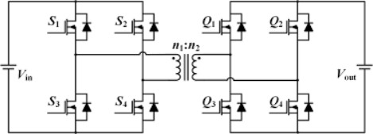

In this circuit, a dc source of 800 V is connected to four MOSFETs as shown in the above figure, and a pulse generator is used. One pulse generator is directly connected to S1 and S4 diagonally. And the same pulse generator is connected via a not gate to S2 and S4. The Same pulse generator is connected to a Phase Changer and a Gainer in series and is further connected to Q1 and Q4 diagonally The Pulse generator is connected via a not gate and is connected to Q2 and Q3. The pulse generator has a 50% duty cycle.

The Linear Transformer used in this circuit has a transformer ratio of 0.5 therefore provided input is 800 V, therefore, the expected output is 420 V.

## **WORKING**

Power transfer happens in a dual-active bridge where two high-frequency square waves are created in the primary and secondary side of the transformer by the switching action of MOSFETs. These high- frequency square waves are phase shifted with respect to each other. Power transfer takes place from the leading bridge to the lagging bridge, and this power flow direction can be easily changed by reversing the phase shift between the two bridges. Hence, it is possible to obtain bidirectional power transfer with ease in a dual-active bridge. In a single-phase, dual-active bridge, primary and secondary bridges are controlled simultaneously. All switches operate at a 50% duty ratio. The diagonal switches turn on and off together so that the output of each bridge is a square wave.

## **WORKING OF MOSFET AT DIFFERENT TIME INTERVALS**

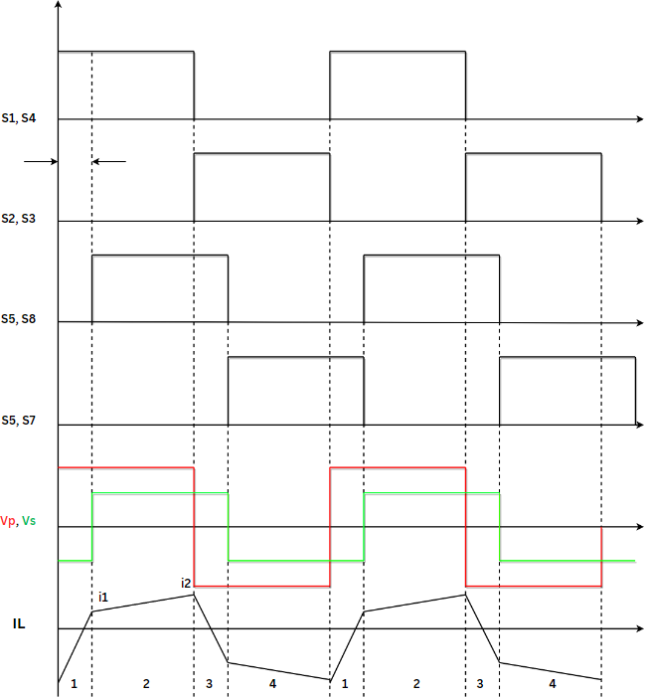

**KEY SYSTEM SPECIFICATIONS**

|  |  |
| --- | --- |
| **PARAMETER** | **SPECIFICATIONS** |
| Input voltage range | 100-200 V |
| Output voltage range | 400-500 V |
| Output power rating | 10-KW maximum |
| Output current | 26-A maximum |
| Efficiency | Peak 98.2% (at 6.6 kW) full load 97.6% (at 10 kW) |
| PWM switching frequency | 100 kHz |
| Power density | >2 kw/L |
| Voltage ripple | <5 % |

## **CIRCUIT ON MATLAB**

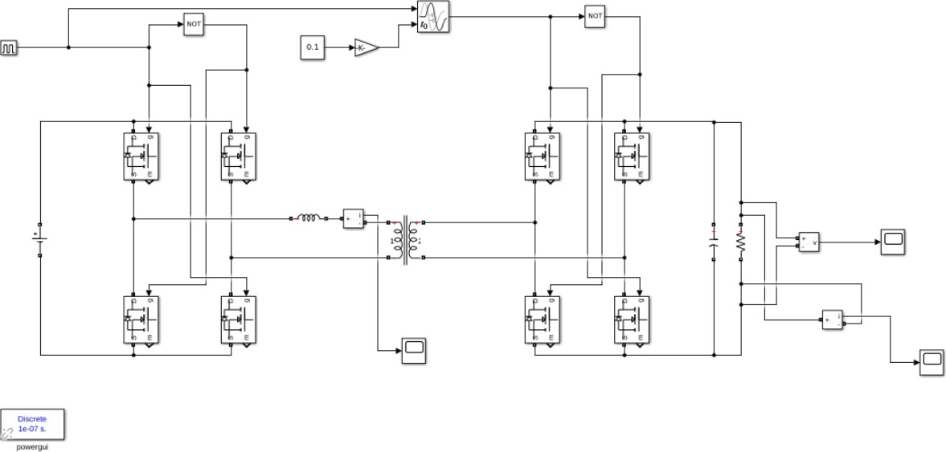

**RESULTS OBTAINED**

# Output Voltage vs Time: -

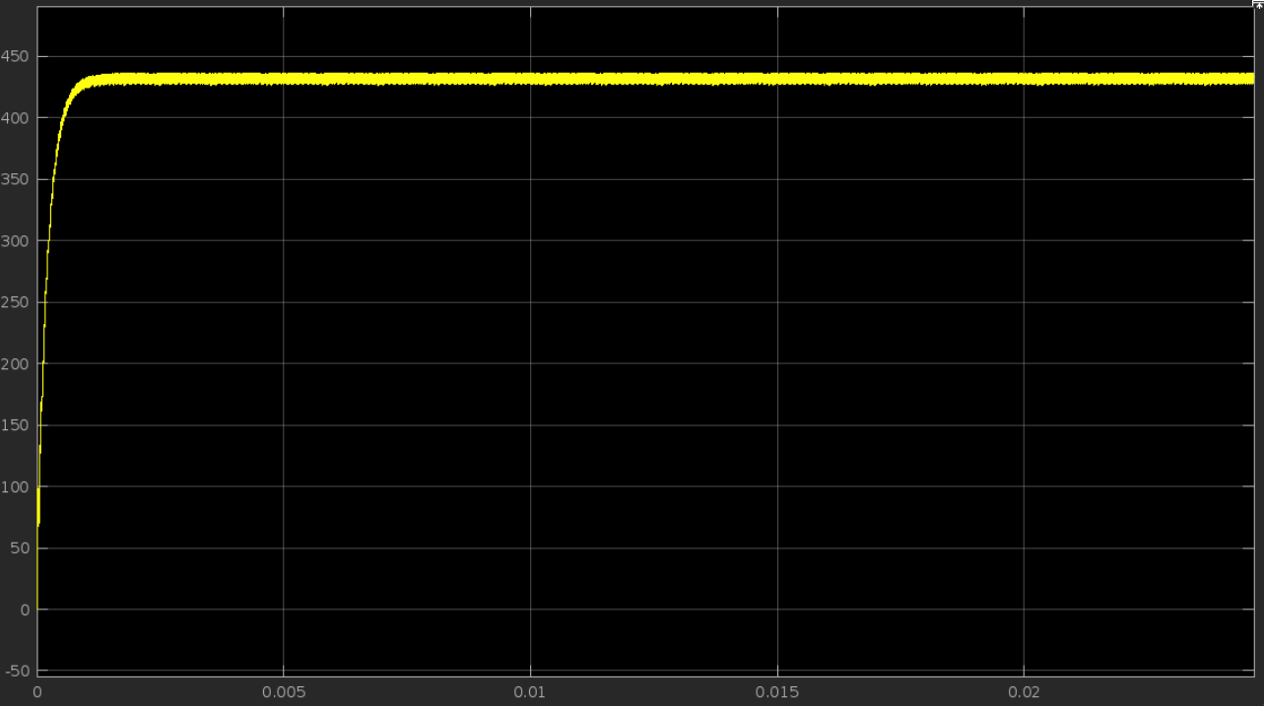

**GRAPH OF V(Input), V2(output), AND CURRENT ACROSS INDUCTOR:**

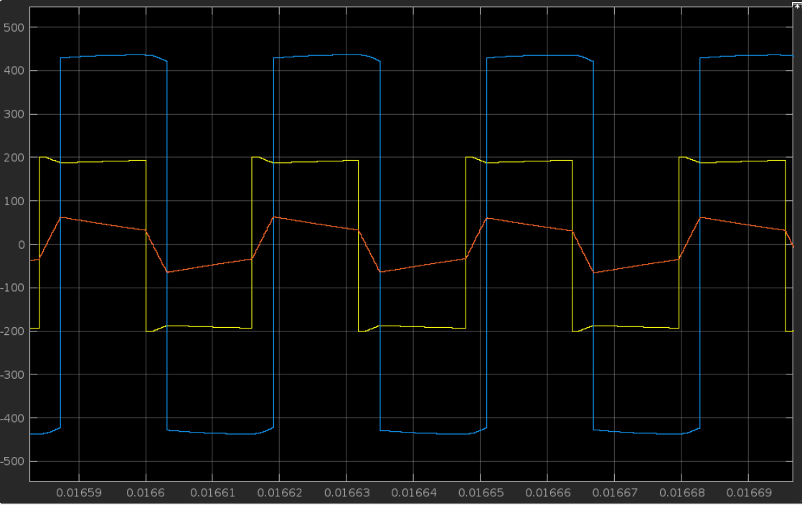

## **CONCLUSION**

the bidirectional battery charger is a complex and sophisticated technology that has significant implications for the efficient and flexible use of energy storage systems. This technology enables power to be transferred in either direction between the battery and the grid, allowing for the effective management of renewable energy sources like solar and wind power. The bidirectional battery charger is based on a dual active bridge converter, which is a power electronics circuit that allows for the regulation of voltage and current levels of the power flowing through it. This technology enables efficient and optimized charging and discharging of the battery, and helps to balance the grid by providing backup power during blackouts and absorbing excess energy during low-demand periods. The bidirectional battery charger has significant potential to revolutionize the way we manage and use energy, and it is becoming increasingly important as the use of renewable energy sources continues to grow.

As this technology continues to advance, it has the potential to significantly reduce our dependence on fossil fuels and help us transition to a more sustainable energy future. Overall, the bidirectional battery charger is an important technological advancement with far-reaching implications for the future of energy management and sustainability.

In addition to its practical applications, the bidirectional battery charger is also a fascinating technology with a wide range of potential uses. For example, it could be used in electric vehicles to allow for bidirectional charging, which would enable the vehicle's battery to be used as a power source for homes or businesses during blackouts or other emergencies. This technology could also be used in microgrids, which are self-contained electrical networks that can operate independently of the main power grid.

Bidirectional battery chargers could help to balance the power supply and demand within a microgrid, allowing for more efficient and stable operation.

Another interesting aspect of bidirectional battery chargers is their potential to support the growth of distributed energy resources (DERs), such as rooftop solar panels or small wind turbines. These resources can generate excess energy that can be stored in batteries for later use, but they can also cause voltage fluctuations and other issues on the grid if not managed properly. Bidirectional battery chargers can help to mitigate these issues by absorbing excess energy during times of high generation and providing backup power during times of low generation.

## **REFERENCES**

1. [https://ecogears.in/complete-guide-to-bidirectional-ev-charging-technology-as-future-of-ev-](https://ecogears.in/complete-guide-to-bidirectional-ev-charging-technology-as-future-of-ev-chargers/) [chargers/](https://ecogears.in/complete-guide-to-bidirectional-ev-charging-technology-as-future-of-ev-chargers/)
2. [https://www.researchgate.net/publication/269269900_Bidirectional_battery_char](https://www.researchgate.net/publication/269269900_Bidirectional_battery_charger_for_electric_vehicle) [ger_for_electric_vehicle](https://www.researchgate.net/publication/269269900_Bidirectional_battery_charger_for_electric_vehicle)
3. [https://www.google.com/imgres?imgurl=https%3A%2F%2Fimages.squarespace-](https://www.google.com/imgres?imgurl=https%3A%2F%2Fimages.squarespace-cdn.com%2Fcontent%2Fv1%2F5354537ce4b0e65f5c20d562%2F3ca6be95-9b3a-46bd-85e8-56b068b6ed44%2FBidirectional_EV-chargers-explained-V2H-V2G.png&imgrefurl=https%3A%2F%2Fwww.cleanenergyreviews.info%2Fblog%2Fbidirectional-ev-charging-v2g-v2h-v2l&tbnid=YcutD90PxD7U9M&vet=12ahUKEwiW5aat6a37AhUVj9gFHVwUBmcQMygAegUIARC3AQ..i&docid=LrKhMPSxwuy43M&w=969&h=367&q=bidirectional%20battery%20charger%20for%20electric%20vehicle&ved=2ahUKEwiW5aat6a37AhUVj9gFHVwUBmcQMygAegUIARC3AQ) [cdn.com%2Fcontent%2Fv1%2F5354537ce4b0e65f5c20d562%2F3ca6be95-](https://www.google.com/imgres?imgurl=https%3A%2F%2Fimages.squarespace-cdn.com%2Fcontent%2Fv1%2F5354537ce4b0e65f5c20d562%2F3ca6be95-9b3a-46bd-85e8-56b068b6ed44%2FBidirectional_EV-chargers-explained-V2H-V2G.png&imgrefurl=https%3A%2F%2Fwww.cleanenergyreviews.info%2Fblog%2Fbidirectional-ev-charging-v2g-v2h-v2l&tbnid=YcutD90PxD7U9M&vet=12ahUKEwiW5aat6a37AhUVj9gFHVwUBmcQMygAegUIARC3AQ..i&docid=LrKhMPSxwuy43M&w=969&h=367&q=bidirectional%20battery%20charger%20for%20electric%20vehicle&ved=2ahUKEwiW5aat6a37AhUVj9gFHVwUBmcQMygAegUIARC3AQ) [9b3a-46bd-85e8-56b068b6ed44%2FBidirectional_EV-chargers-explained-V2H-](https://www.google.com/imgres?imgurl=https%3A%2F%2Fimages.squarespace-cdn.com%2Fcontent%2Fv1%2F5354537ce4b0e65f5c20d562%2F3ca6be95-9b3a-46bd-85e8-56b068b6ed44%2FBidirectional_EV-chargers-explained-V2H-V2G.png&imgrefurl=https%3A%2F%2Fwww.cleanenergyreviews.info%2Fblog%2Fbidirectional-ev-charging-v2g-v2h-v2l&tbnid=YcutD90PxD7U9M&vet=12ahUKEwiW5aat6a37AhUVj9gFHVwUBmcQMygAegUIARC3AQ..i&docid=LrKhMPSxwuy43M&w=969&h=367&q=bidirectional%20battery%20charger%20for%20electric%20vehicle&ved=2ahUKEwiW5aat6a37AhUVj9gFHVwUBmcQMygAegUIARC3AQ) [V2G.png&imgrefurl=https%3A%2F%2Fwww.cleanenergyreviews.info%2Fblog](https://www.google.com/imgres?imgurl=https%3A%2F%2Fimages.squarespace-cdn.com%2Fcontent%2Fv1%2F5354537ce4b0e65f5c20d562%2F3ca6be95-9b3a-46bd-85e8-56b068b6ed44%2FBidirectional_EV-chargers-explained-V2H-V2G.png&imgrefurl=https%3A%2F%2Fwww.cleanenergyreviews.info%2Fblog%2Fbidirectional-ev-charging-v2g-v2h-v2l&tbnid=YcutD90PxD7U9M&vet=12ahUKEwiW5aat6a37AhUVj9gFHVwUBmcQMygAegUIARC3AQ..i&docid=LrKhMPSxwuy43M&w=969&h=367&q=bidirectional%20battery%20charger%20for%20electric%20vehicle&ved=2ahUKEwiW5aat6a37AhUVj9gFHVwUBmcQMygAegUIARC3AQ)

[%2Fbidirectional-ev-charging-v2g-v2h-](https://www.google.com/imgres?imgurl=https%3A%2F%2Fimages.squarespace-cdn.com%2Fcontent%2Fv1%2F5354537ce4b0e65f5c20d562%2F3ca6be95-9b3a-46bd-85e8-56b068b6ed44%2FBidirectional_EV-chargers-explained-V2H-V2G.png&imgrefurl=https%3A%2F%2Fwww.cleanenergyreviews.info%2Fblog%2Fbidirectional-ev-charging-v2g-v2h-v2l&tbnid=YcutD90PxD7U9M&vet=12ahUKEwiW5aat6a37AhUVj9gFHVwUBmcQMygAegUIARC3AQ..i&docid=LrKhMPSxwuy43M&w=969&h=367&q=bidirectional%20battery%20charger%20for%20electric%20vehicle&ved=2ahUKEwiW5aat6a37AhUVj9gFHVwUBmcQMygAegUIARC3AQ) [v2l&tbnid=YcutD90PxD7U9M&vet=12ahUKEwiW5aat6a37AhUVj9gFHVwU](https://www.google.com/imgres?imgurl=https%3A%2F%2Fimages.squarespace-cdn.com%2Fcontent%2Fv1%2F5354537ce4b0e65f5c20d562%2F3ca6be95-9b3a-46bd-85e8-56b068b6ed44%2FBidirectional_EV-chargers-explained-V2H-V2G.png&imgrefurl=https%3A%2F%2Fwww.cleanenergyreviews.info%2Fblog%2Fbidirectional-ev-charging-v2g-v2h-v2l&tbnid=YcutD90PxD7U9M&vet=12ahUKEwiW5aat6a37AhUVj9gFHVwUBmcQMygAegUIARC3AQ..i&docid=LrKhMPSxwuy43M&w=969&h=367&q=bidirectional%20battery%20charger%20for%20electric%20vehicle&ved=2ahUKEwiW5aat6a37AhUVj9gFHVwUBmcQMygAegUIARC3AQ) [BmcQMygAegUIARC3AQ..i&docid=LrKhMPSxwuy43M&w=969&h=367&q=](https://www.google.com/imgres?imgurl=https%3A%2F%2Fimages.squarespace-cdn.com%2Fcontent%2Fv1%2F5354537ce4b0e65f5c20d562%2F3ca6be95-9b3a-46bd-85e8-56b068b6ed44%2FBidirectional_EV-chargers-explained-V2H-V2G.png&imgrefurl=https%3A%2F%2Fwww.cleanenergyreviews.info%2Fblog%2Fbidirectional-ev-charging-v2g-v2h-v2l&tbnid=YcutD90PxD7U9M&vet=12ahUKEwiW5aat6a37AhUVj9gFHVwUBmcQMygAegUIARC3AQ..i&docid=LrKhMPSxwuy43M&w=969&h=367&q=bidirectional%20battery%20charger%20for%20electric%20vehicle&ved=2ahUKEwiW5aat6a37AhUVj9gFHVwUBmcQMygAegUIARC3AQ) [bidirectional%20battery%20charger%20for%20electric%20vehicle&ved=2ahUK](https://www.google.com/imgres?imgurl=https%3A%2F%2Fimages.squarespace-cdn.com%2Fcontent%2Fv1%2F5354537ce4b0e65f5c20d562%2F3ca6be95-9b3a-46bd-85e8-56b068b6ed44%2FBidirectional_EV-chargers-explained-V2H-V2G.png&imgrefurl=https%3A%2F%2Fwww.cleanenergyreviews.info%2Fblog%2Fbidirectional-ev-charging-v2g-v2h-v2l&tbnid=YcutD90PxD7U9M&vet=12ahUKEwiW5aat6a37AhUVj9gFHVwUBmcQMygAegUIARC3AQ..i&docid=LrKhMPSxwuy43M&w=969&h=367&q=bidirectional%20battery%20charger%20for%20electric%20vehicle&ved=2ahUKEwiW5aat6a37AhUVj9gFHVwUBmcQMygAegUIARC3AQ) [EwiW5aat6a37AhUVj9gFHVwUBmcQMygAegUIARC3AQ](https://www.google.com/imgres?imgurl=https%3A%2F%2Fimages.squarespace-cdn.com%2Fcontent%2Fv1%2F5354537ce4b0e65f5c20d562%2F3ca6be95-9b3a-46bd-85e8-56b068b6ed44%2FBidirectional_EV-chargers-explained-V2H-V2G.png&imgrefurl=https%3A%2F%2Fwww.cleanenergyreviews.info%2Fblog%2Fbidirectional-ev-charging-v2g-v2h-v2l&tbnid=YcutD90PxD7U9M&vet=12ahUKEwiW5aat6a37AhUVj9gFHVwUBmcQMygAegUIARC3AQ..i&docid=LrKhMPSxwuy43M&w=969&h=367&q=bidirectional%20battery%20charger%20for%20electric%20vehicle&ved=2ahUKEwiW5aat6a37AhUVj9gFHVwUBmcQMygAegUIARC3AQ)

1. [https://www.ijert.org/design-and-analysis-of-bidirectional-battery-charger-for-](https://www.ijert.org/design-and-analysis-of-bidirectional-battery-charger-for-electric-vehicle) [electric-vehicle](https://www.ijert.org/design-and-analysis-of-bidirectional-battery-charger-for-electric-vehicle)
2. [https://www.researchgate.net/publication/269269900_Bidirectional_battery_char](https://www.researchgate.net/publication/269269900_Bidirectional_battery_charger_for_electric_vehicle) [ger_for_electric_vehicle](https://www.researchgate.net/publication/269269900_Bidirectional_battery_charger_for_electric_vehicle)
3. [https://www.ti.com/lit/ug/tidues0c/tidues0c.pdf?ts=1659098208093&ref_url=http](https://www.ti.com/lit/ug/tidues0c/tidues0c.pdf?ts=1659098208093&ref_url=https%253A%252F%252Fwww.google.com%252F) [s%253A%252F%252Fwww.google.com%252F](https://www.ti.com/lit/ug/tidues0c/tidues0c.pdf?ts=1659098208093&ref_url=https%253A%252F%252Fwww.google.com%252F)
4. [https://www.google.com/imgres?imgurl=https%3A%2F%2Fwww.energy.gov%2](https://www.google.com/imgres?imgurl=https%3A%2F%2Fwww.energy.gov%2Fsites%2Fdefault%2Ffiles%2Fstyles%2Ffull_article_width%2Fpublic%2F2022-02%2Fbidirectional-charging.png%3Fitok%3DLJw-VFts&imgrefurl=https%3A%2F%2Fwww.energy.gov%2Feere%2Ffemp%2Fbidirectional-charging-and-electric-vehicles-mobile-storage&tbnid=x0gJVD7V7KAdaM&vet=12ahUKEwix_8Gy6637AhXWDbcAHQdmAlwQMygUegUIARDhAQ..i&docid=3TdB32tRLxbZrM&w=820&h=527&q=bidirectional%20battery%20charger%20for%20electric%20vehicle%20v2g&ved=2ahUKEwix_8Gy6637AhXWDbcAHQdmAlwQMygUegUIARDhAQ) [Fsites%2Fdefault%2Ffiles%2Fstyles%2Ffull_article_width%2Fpublic%2F2022-](https://www.google.com/imgres?imgurl=https%3A%2F%2Fwww.energy.gov%2Fsites%2Fdefault%2Ffiles%2Fstyles%2Ffull_article_width%2Fpublic%2F2022-02%2Fbidirectional-charging.png%3Fitok%3DLJw-VFts&imgrefurl=https%3A%2F%2Fwww.energy.gov%2Feere%2Ffemp%2Fbidirectional-charging-and-electric-vehicles-mobile-storage&tbnid=x0gJVD7V7KAdaM&vet=12ahUKEwix_8Gy6637AhXWDbcAHQdmAlwQMygUegUIARDhAQ..i&docid=3TdB32tRLxbZrM&w=820&h=527&q=bidirectional%20battery%20charger%20for%20electric%20vehicle%20v2g&ved=2ahUKEwix_8Gy6637AhXWDbcAHQdmAlwQMygUegUIARDhAQ) [02%2Fbidirectional-charging.png%3Fitok%3DLJw-](https://www.google.com/imgres?imgurl=https%3A%2F%2Fwww.energy.gov%2Fsites%2Fdefault%2Ffiles%2Fstyles%2Ffull_article_width%2Fpublic%2F2022-02%2Fbidirectional-charging.png%3Fitok%3DLJw-VFts&imgrefurl=https%3A%2F%2Fwww.energy.gov%2Feere%2Ffemp%2Fbidirectional-charging-and-electric-vehicles-mobile-storage&tbnid=x0gJVD7V7KAdaM&vet=12ahUKEwix_8Gy6637AhXWDbcAHQdmAlwQMygUegUIARDhAQ..i&docid=3TdB32tRLxbZrM&w=820&h=527&q=bidirectional%20battery%20charger%20for%20electric%20vehicle%20v2g&ved=2ahUKEwix_8Gy6637AhXWDbcAHQdmAlwQMygUegUIARDhAQ) [VFts&imgrefurl=https%3A%2F%2Fwww.energy.gov%2Feere%2Ffemp%2Fbidi](https://www.google.com/imgres?imgurl=https%3A%2F%2Fwww.energy.gov%2Fsites%2Fdefault%2Ffiles%2Fstyles%2Ffull_article_width%2Fpublic%2F2022-02%2Fbidirectional-charging.png%3Fitok%3DLJw-VFts&imgrefurl=https%3A%2F%2Fwww.energy.gov%2Feere%2Ffemp%2Fbidirectional-charging-and-electric-vehicles-mobile-storage&tbnid=x0gJVD7V7KAdaM&vet=12ahUKEwix_8Gy6637AhXWDbcAHQdmAlwQMygUegUIARDhAQ..i&docid=3TdB32tRLxbZrM&w=820&h=527&q=bidirectional%20battery%20charger%20for%20electric%20vehicle%20v2g&ved=2ahUKEwix_8Gy6637AhXWDbcAHQdmAlwQMygUegUIARDhAQ) [rectional-charging-and-electric-vehicles-mobile-](https://www.google.com/imgres?imgurl=https%3A%2F%2Fwww.energy.gov%2Fsites%2Fdefault%2Ffiles%2Fstyles%2Ffull_article_width%2Fpublic%2F2022-02%2Fbidirectional-charging.png%3Fitok%3DLJw-VFts&imgrefurl=https%3A%2F%2Fwww.energy.gov%2Feere%2Ffemp%2Fbidirectional-charging-and-electric-vehicles-mobile-storage&tbnid=x0gJVD7V7KAdaM&vet=12ahUKEwix_8Gy6637AhXWDbcAHQdmAlwQMygUegUIARDhAQ..i&docid=3TdB32tRLxbZrM&w=820&h=527&q=bidirectional%20battery%20charger%20for%20electric%20vehicle%20v2g&ved=2ahUKEwix_8Gy6637AhXWDbcAHQdmAlwQMygUegUIARDhAQ) [storage&tbnid=x0gJVD7V7KAdaM&vet=12ahUKEwix_8Gy6637AhXWDbcA](https://www.google.com/imgres?imgurl=https%3A%2F%2Fwww.energy.gov%2Fsites%2Fdefault%2Ffiles%2Fstyles%2Ffull_article_width%2Fpublic%2F2022-02%2Fbidirectional-charging.png%3Fitok%3DLJw-VFts&imgrefurl=https%3A%2F%2Fwww.energy.gov%2Feere%2Ffemp%2Fbidirectional-charging-and-electric-vehicles-mobile-storage&tbnid=x0gJVD7V7KAdaM&vet=12ahUKEwix_8Gy6637AhXWDbcAHQdmAlwQMygUegUIARDhAQ..i&docid=3TdB32tRLxbZrM&w=820&h=527&q=bidirectional%20battery%20charger%20for%20electric%20vehicle%20v2g&ved=2ahUKEwix_8Gy6637AhXWDbcAHQdmAlwQMygUegUIARDhAQ) [HQdmAlwQMygUegUIARDhAQ..i&docid=3TdB32tRLxbZrM&w=820&h=52](https://www.google.com/imgres?imgurl=https%3A%2F%2Fwww.energy.gov%2Fsites%2Fdefault%2Ffiles%2Fstyles%2Ffull_article_width%2Fpublic%2F2022-02%2Fbidirectional-charging.png%3Fitok%3DLJw-VFts&imgrefurl=https%3A%2F%2Fwww.energy.gov%2Feere%2Ffemp%2Fbidirectional-charging-and-electric-vehicles-mobile-storage&tbnid=x0gJVD7V7KAdaM&vet=12ahUKEwix_8Gy6637AhXWDbcAHQdmAlwQMygUegUIARDhAQ..i&docid=3TdB32tRLxbZrM&w=820&h=527&q=bidirectional%20battery%20charger%20for%20electric%20vehicle%20v2g&ved=2ahUKEwix_8Gy6637AhXWDbcAHQdmAlwQMygUegUIARDhAQ) [7&q=bidirectional%20battery%20charger%20for%20electric%20vehicle%20v2g](https://www.google.com/imgres?imgurl=https%3A%2F%2Fwww.energy.gov%2Fsites%2Fdefault%2Ffiles%2Fstyles%2Ffull_article_width%2Fpublic%2F2022-02%2Fbidirectional-charging.png%3Fitok%3DLJw-VFts&imgrefurl=https%3A%2F%2Fwww.energy.gov%2Feere%2Ffemp%2Fbidirectional-charging-and-electric-vehicles-mobile-storage&tbnid=x0gJVD7V7KAdaM&vet=12ahUKEwix_8Gy6637AhXWDbcAHQdmAlwQMygUegUIARDhAQ..i&docid=3TdB32tRLxbZrM&w=820&h=527&q=bidirectional%20battery%20charger%20for%20electric%20vehicle%20v2g&ved=2ahUKEwix_8Gy6637AhXWDbcAHQdmAlwQMygUegUIARDhAQ) [&ved=2ahUKEwix_8Gy6637AhXWDbcAHQdmAlwQMygUegUIARDhAQ](https://www.google.com/imgres?imgurl=https%3A%2F%2Fwww.energy.gov%2Fsites%2Fdefault%2Ffiles%2Fstyles%2Ffull_article_width%2Fpublic%2F2022-02%2Fbidirectional-charging.png%3Fitok%3DLJw-VFts&imgrefurl=https%3A%2F%2Fwww.energy.gov%2Feere%2Ffemp%2Fbidirectional-charging-and-electric-vehicles-mobile-storage&tbnid=x0gJVD7V7KAdaM&vet=12ahUKEwix_8Gy6637AhXWDbcAHQdmAlwQMygUegUIARDhAQ..i&docid=3TdB32tRLxbZrM&w=820&h=527&q=bidirectional%20battery%20charger%20for%20electric%20vehicle%20v2g&ved=2ahUKEwix_8Gy6637AhXWDbcAHQdmAlwQMygUegUIARDhAQ)
5. <https://yocharge.com/in/ev/chargers/bi-directional/>
6. [https://blog.wallbox.com/why-bidirectional-charging-is-the-next-big-thing-for-](https://blog.wallbox.com/why-bidirectional-charging-is-the-next-big-thing-for-ev-owners/) [ev-owners/](https://blog.wallbox.com/why-bidirectional-charging-is-the-next-big-thing-for-ev-owners/)